Shashank Thakare

Assignment 15th July 2019

Q1. what is Entity Relationship Diagram?

A. An Entity Relationship (ER) Diagram is a type of flowchart that illustrates how “entities” such as people, objects or concepts relate to each other within a system. ER Diagrams are most often used to design or debug relational databases in the fields of software engineering, business information systems, education and research.

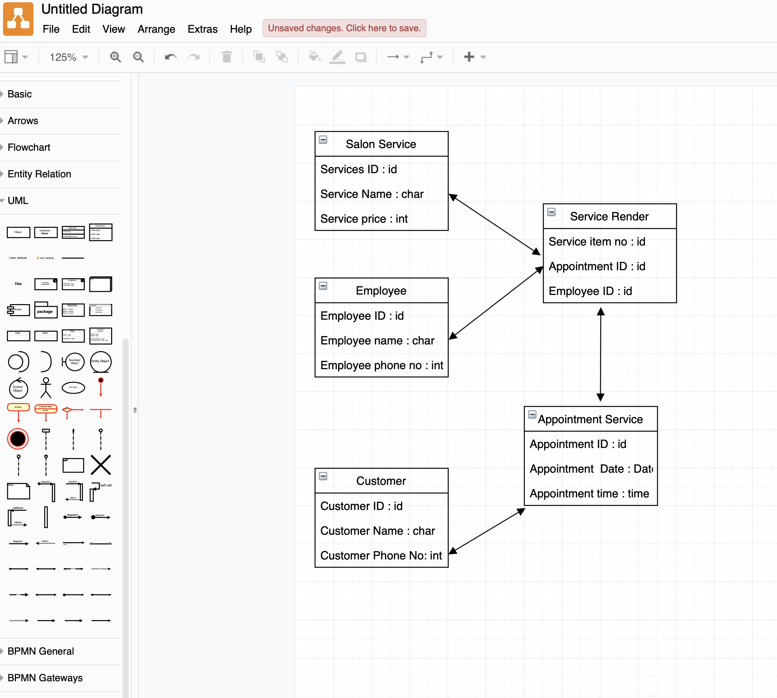ER diagrams are related to data structure diagrams (DSDs), which focus on the relationships of elements within entities instead of relationships between entities themselves.